

Precision Defense Services

INGENIOUS GENIUSES



March 12, 2017

**OMIS 651-BUSINESS SYSTEMS ANALYSIS AND DESIGN**

**By**

**Sankeerth Koppuravuri (Z1777808)**

**INTRODUCTION**

There’s a popular saying that, a chain is only as strong as its weakest link.  The same is true for complex systems.  In the increasingly intricate world of technology, the performance of entire systems rests on the integrity of each of its components.  That is why selecting a supplier is such crucial decision.  For years’ customers have chosen PDS when they require precision machine components and assemblies to support their demanding project requirements.

Precision Defense Services (PDS) has been producing the highest quality precision machined parts for more than 60 years, providing service and components to many of the top aerospace and defense companies like Boeing and Bell Helicopter. It is a Flight safety certified supplier and consists of highly skilled and dedicated journeyman machinists and toolmakers.

PDS management team is committed to the continual improvement to every aspect of its business. Building on the talent and knowledge of its experienced staff, PDS is continually extending its capabilities by acquiring new technologies and equipment to maintain the company’s industry leadership.

Philosophies that PDS follow are

* Do it right the first time
* Develop strong professional relationships with our customers
* Use a team approach to problem solving in order to utilize the knowledge and talents that each of our people bring to the project
* Continually extend our capabilities by acquiring new technologies and equipment to maintain our industry leadership

**CURRENT SYSTEM**

The company’s custom-made legacy systems were cumbersome and designed to perform only specific groups of tasks. Due to this many problems arose and the company also had opportunities for taking the step of implementing an ERP system.

**Sales and order management:**

The current sales and order management system involves much more than taking order and shipping items

When a customer approaches manufacturing firm with the order. The order details are taken and forwarded to inventory management. Where they check the effort that is needed to finish the order such as labor hours, cost, duration and many others and decide whether they can take up the order or not.

**Inventory Management:**

Inventory management critical to a firm’s strategic viability. The received orders are then forwarded to inventory department. The inventory management then checks for the items in the inventory. There is a separate inventory file where it checks for the availability of the items. If any item is not present in the inventory it places orders with the suppliers. There are multiple suppliers for the company.

**Quality management:**

A QMS enables an organization to achieve the goals and objectives set out in its policy and strategy. It provides consistency and satisfaction in terms of methods, materials, equipment, etc, and interacts with all activities of the organization, beginning with the identification of customer requirements and ending with their satisfaction, at every transaction interface. The current system checks every item when it is being sent from inventory management to the production. Documents the quality of the part in as per the norms and standards.

**Production control management:**

After going through the quality management all the parts come to the production which is the heart of the organization. This typically involves the following processes

* ***Production planning*.** During production planning, managers determine how goods will be produced, where production will take place, and how manufacturing facilities will be laid out.
* ***Production control*.** Once the production process is under way, managers must continually schedule and monitor the activities that make up that process. They must solicit and respond to feedback and make adjustments where needed. At this stage, they also oversee the purchasing of raw materials and the handling of inventories.
* ***Quality control*.** Finally, the operations manager is directly involved in efforts to ensure that goods are produced according to specifications and that quality standards are maintained.

**Finance management:**

Financial management is very important, particularly accurate and reliable for planning costs. This takes care of all the transactions internally and external of the organization. Internal activities involves tracking the costs of raw materials, labor, packaging, supplying etc. External involves dealing with the customer, suppliers etc. The project budget should be approved by the project sponsor and a financial expense form is created. The incoming expenses are documented. It needs approval from the sponsor if it is unplanned. Now the project plan is updated in the project file. Finally the document is submitted to the sponsor.

**Shipping and distribution:**

All the shipping related works are handledby the shipping department. First the items are shipped from inventory to production centre. Finally when the production is finished the items are shipped to the customer.

**Current system Problems:**

**Problem 1: Order Status / Confirmation Status:**

Currently in PDS when a vendor places an order, this order notification is received by the **order management**. This department upon receiving the order has to contact the internal departments like:

* **Inventory management department** for the spares required for the manufacturing of the order placed by the vendor.
* **CAD/CAM department** for designing the product ordered by the vendor.
* Or any other department based on the order placed by the customer.

For confirming the order the Transactions department has to contact the above mentioned departments. During this time all along the order status is put on pending which is not a good sign from vendor’s point of view. Some vendors might even cancel the order and contact PDS competitors for same products.

**Problem 2:**

Halt in the manufacturing process as the inventory management waits till all the items are gathered, only then the items are forwarded to the production department. This delays all the manufacturing processes which results for late deliveries of the finished products.

**Problem-3:**

When the inventory is short of items they request supplier to send for the items. Sometimes the supplier is also short of the items which results in generating another request to another supplier which is a extra work for the inventory department again resulting in a delay of procurement of items also delaying manufacturing process.

**Problem-4:**

All the products should be in update with the industry standards. Since we have quality assurance department inside the company, they check the quality standards after the items are shipped to the company. In some cases the items don’t satisfy the updated industry standards and we have to resend the items back to the supplier and make them update the standards which results in delay of manufacturing process.

**Proposed system:**

We propose to implement an ERP solution called **EPICOR** which connects every department at a place and introduces few new departments which speeds up the business processes which results in faster production, procurement and delivering of goods to the customer with high quality.

Epicor understands that as an aerospace and defense (A&D) manufacturer, you must identify, consider, and respond to a new set of challenges each day. Change in this industry is a given; managing the change with tools and services to distinguish your business from local and global competition is fundamental. With increasing pressure to reduce prices in a business climate of expanding raw material cost and reduced labor availability, businesses like yours are streamlining and adopting new technology to automate business processes for more competitive lead times and to reduce waste in the organization. Epicor for Aerospace and Defense is a global enterprise resource planning software solution designed for manufacturing organizations who supply products and services to the aerospace and defense industry.

With Epicor, the company would gain a powerful end-to-end, value-chain solution to manage key infrastructure and support its unique manufacturing and business needs. Epicor would take PDS’s business to the next level by replacing cumbersome manual processes and consolidating multiple legacy systems with a fully-integrated single-source ERP solution. The impact of Epicor will be immediately felt throughout the enterprise, improving efficiencies on the shop floor as well as the back office. With Epicor PDS would easily adopt new technologies and best business practices to save money and improve the overall management of the company. The flexibility of Epicor would allow PDS to be more nimble and proactive to keep them competitive in today’s changing market conditions.

Epicor helps PDS to comply with the strict regulations and standards inherent to the aerospace and defense industry, allowing PDS to be more efficient at what they do best. One of the biggest opportunities for PDS is utilizing Epicor to automate its shop floor operations. Epicor provides automation and real- time visibility, giving PDS complete business control and transparency that provides greater responsiveness, accuracy and performance.Performance optimization is critical to the overall success of PDS’ process improvement initiative. EPICOR would help PDS to improve throughput on the shop floor, helping to eliminate human errors, save staff time and improve quality management. Automated scheduling would lead to better lead time and forecast accuracies, as well as quicker delivery dates, helping PDS to better compete in the aerospace and defense industry by improving their customer satisfaction and response time. With Epicor, PDS will become a better partner to its customers by improving their internal efficiencies which in turn create cost advantages to their customers.Lending to its ease-of-use and service-oriented architecture (SOA), Epicor brings people, processes and applications closer together — increasing efficiency and collaboration. Epicor benefits every department within the company, improving collaboration and increasing productivity by tightly integrating its shop floor workers with the rest of the enterprise.

Improving capabilities in the areas of quality, productivity, cost and delivery is at the core of PDS’ corporate initiative. PDS wants their customers to know that the company is continually making process improvements so they can provide the highest-level of support to meet their customer‘s most demanding project requirements. PDS’ vision for its process improvement initiative is to enhance the overall image of the company and to let customers know that PDS is utilizing the best in technology to provide world-class products and services, creating a more valuable and competitive organization that will ultimately benefit its customers by cutting costs, and delivering new products and services with greater speed and accuracy.

**Epicor Main Functionalities:**

* Embedded project management supports efficient cost and schedule visibility
* Product Lifecycle Management (PLM) for complex engineering-intensive product control
* Supports engineer-to-order and mixed-mode manufacturing
* Embedded robust quality management to support stringent regulatory requirements

**Factors responsible for the ERP implementation:**

1. To send the project estimate faster to the customer we propose to develop planning and scheduling department. This develops a master scheduling process which automates the scheduling and planning. It handles capacity and materials planning efficiently by creating an estimate as soon as the customer places an order. Thus sending faster project estimate reports to the customer.
2. Since even the suppliers are also short of some materials which creates delay in materials procurement we create a new bidding process among the suppliers which makes sure which supplier has all the requested materials and that particular supplier’s bids for the order.
3. Since there is an issue with the quality assurance of the products we extend our present quality management functionality. We implement a process which checks the quality standards before the items are shipped to the inventory. In this way we can rectify the issue.
4. Since the inventory waits for all the items to get stacked up this creates a delay in manufacturing process. We develop a process which generates a planned report which analyses the manufacturing process with the items which we have in the inventory readily. Thus we don’t have to wait for all the items to get stacked up, instead forwarding the items which we have in the inventory readily and start the related manufacturing processes.

**SWOT Analysis:**

Precision Defense Services is one of top companies in the industry of metal casting and industrial goods. The company produces forged components, industrial gas turbines, airfoil casting used for engines of aircrafts and investment castings. Many crucial aircraft manufacturers depend upon the products from Precision Defense Services.

**Strengths:**

* Precision Defense Services is leading producers of components of aerospace industry especially of jet engine.
* Company also produces other industrial components such as parts of medical prostheses, oil industry parts and parts of power generating turbines.
* For electricity turbines Precision Defense Services are considered as most prominent manufacturers for gas turbines.
* $1.5million revenue is earned by the company from manufacturing of parts for Boeing 787.
* PDS holds fair share of markets in Europe, Asia and US.
* PDS has acquired 362 positions in list of Fortune 500 in year 2009.
* PDS is also ranked as 11th best company for production of Defense and Aerospace products.
* The strong position of company is due to its variety of product range as it accommodates different types of industries.
* Precision Defense Services puts great effort in research and development activities to meet standard of industry.
* Due to industrial growth PDS holds strong prospects for growth.
* The annual growth rate of revenue of company is about 13.94%.

**Weakness:**

* Due to economic recession all over the world acquisitions become more expensive and also increase risk involved in it.
* Precision Defense Services also exhibit decrease in market share.
* PDS depends on limited numbers of available customers for its revenues.
* Due to worldwide economic downfall company also has to face reduced in number of orders from industries.

**Opportunities:**

* Due to increase in prices of fuel demand for industrial parts for alternative transportation increases.
* Precision Defense services can explore more opportunities with emerging markets such as India and China.
* With more advance upcoming technologies PDS can introduce more innovative products.
* With increase in defense budget in US more orders are available for company for defense industry.
* Precision Defense Services is leading producers of components of aerospace industry especially of jet engine.

**Threats:**

* Precision Defense Services has to face competitions from emerging industries in production of different products such as Howmet in casting products, Ladish Co for segment of forged products and many other companies for fastener products.
* Economic decline also affects the revenue of company as purchasing power of industry reduced with government policies.
* Reduced growth in markets of US also influence the company revenues.
* The unstable prices of raw material also effect the production of Precision Defense Services.

Part-2: Analysis

In order to provide a detailed analysis to the system, we came up with data flow diagrams for current and proposed systems as an attempt to show the data flow in the system.

**Current System**

We drew the context level diagram to understand the functioning of the system and level 0 diagram to denote the data flow and processes, based on the current system that we described earlier.

**Current System Context Level:**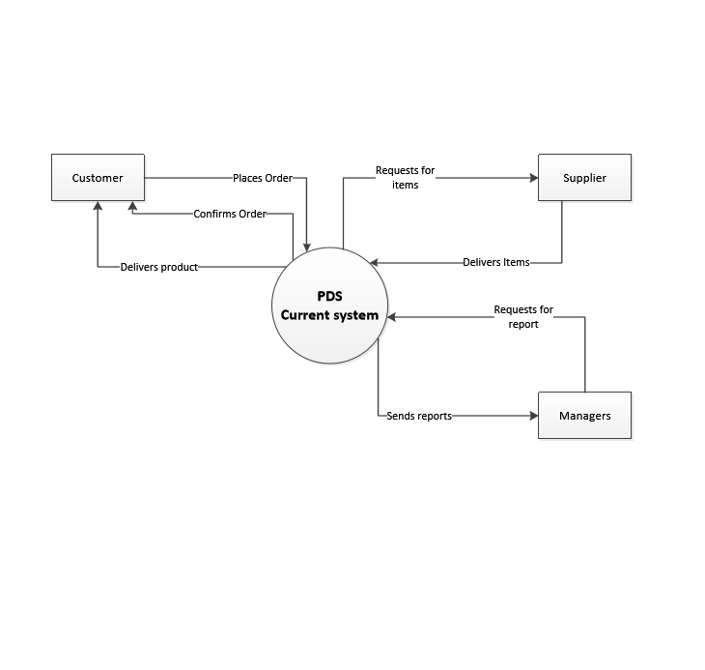

**Current System Level 0:**

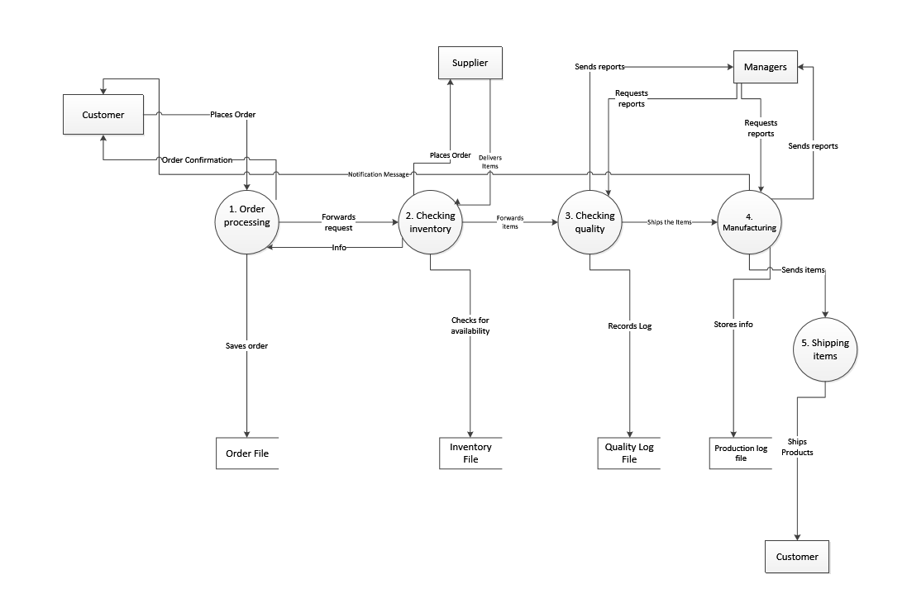

Precision Defense Services (PDS) provides service and components to many of the top aerospace and defense companies like Boeing and Bell Helicopter. It is a Flight safety certified supplier and consists of highly skilled and dedicated journeyman machinists and toolmakers.

1. Initially Customer places the order for which he gets the confirmation once after the process starts.
2. Then it forwards the request to Inventory Management Team which checks the availability of Items with them. If incase any shortage occurs they will place the order to supplier.
3. Once after the supplier delivers the items to Inventory team, it forwards the whole items for Quality check
4. Then it ships to Manufacturing team which further ships the items to respective customers.
5. Each and every report is shared to Manager for his reference.

**Processes Involved:**

* Order Processing
* Checking Inventory
* Checking Quality
* Manufacturing
* Shipping Items

**Data Stores:**

* Order File
* Inventory File
* Quality Log File
* Production Log File

**Proposed Context Level:**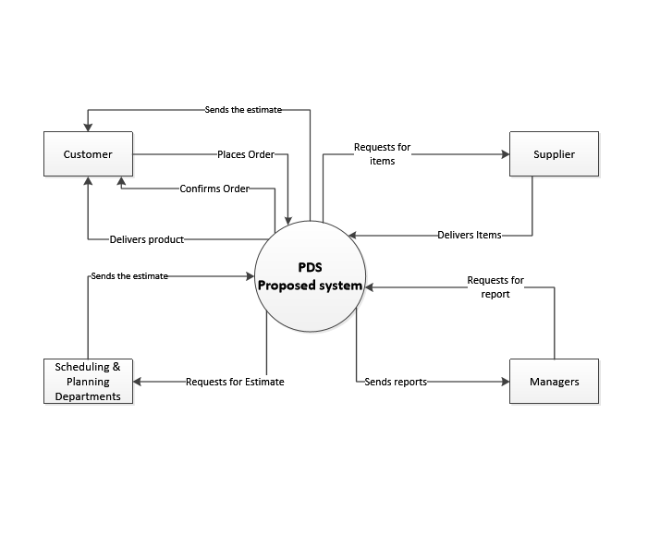

**Proposed System Level 0:**

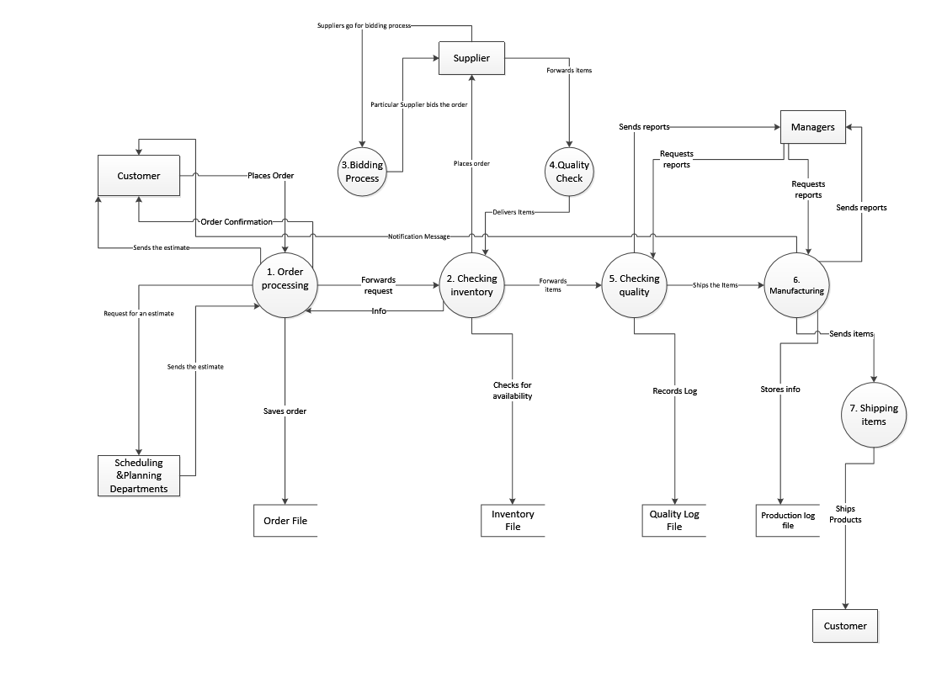

When compared to Current System we have included the points given below

1. We have added Scheduling and Planning Departments which handles capacity and materials planning efficiently by creating an estimate as soon as the customer places an order, thus sending faster project estimate reports to the customer.

2. We have created a Bidding Process among the suppliers because when the suppliers are short of some materials which creates delay in materials procurement thereby bidding process makes sure that which supplier has all the requested materials and that particular suppliers bids for the order.

3. We implemented a process which checks the quality standards before the items are shipped to the inventory. In this way we can resend the items to supplier then and there if there is any problem occurred with the items received so that it saves the time when compared to the previous system.

**Processes Involved:**

* Order Processing
* Checking Inventory
* Bidding Process
* Quality Check before delivering to Inventory
* Checking Quality
* Manufacturing
* Shipping Items

**Data Stores:**

* Order File
* Inventory File
* Quality Log File
* Production Log File

**USER STORIES:**

1. As a quality tester I would like to test the quality of the products received from the suppliers and report results to PDS management.
2. As a Manager I want an interactive report to analyze actual versus budget costs so that the project is on budget.
3. As a vendor I want to search for a product by title so that I can find the required product.
4. As a registered vendor/user I want to log in so that I can access the subscriber content.
5. As a Floor Manager I want to automate all the floor operations so that I can improve production efficiency.
6. As a PDS owner I want to improve business processes to gain competitiveness on the market.
7. As a registered vendor/user I want to place spares order so that I can assemble it into my final product.
8. As a PDS executive I want to generate a report to understand which departments need to improve their productivity.

**Test Case 1:**

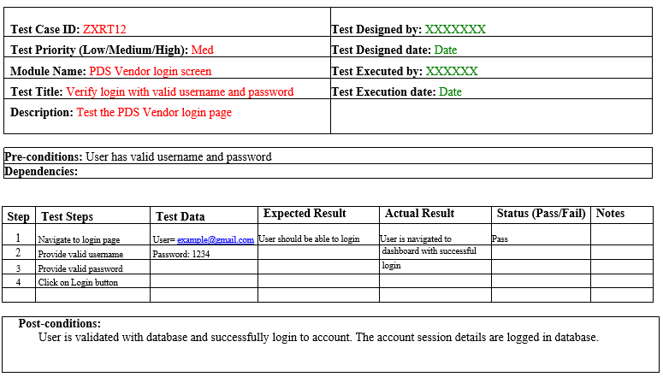

**Test Case 2:**

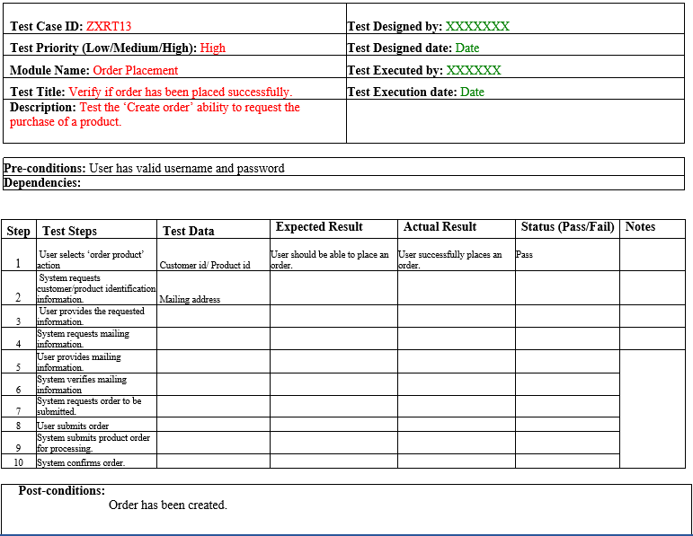

**Part-3**

**Structure chart**

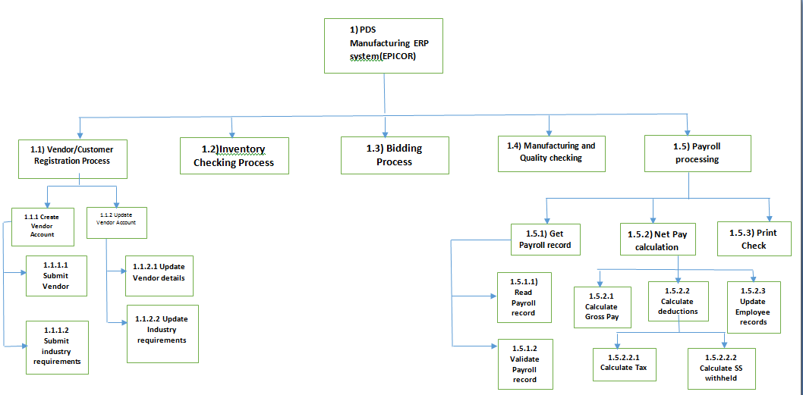

**Class Diagram**

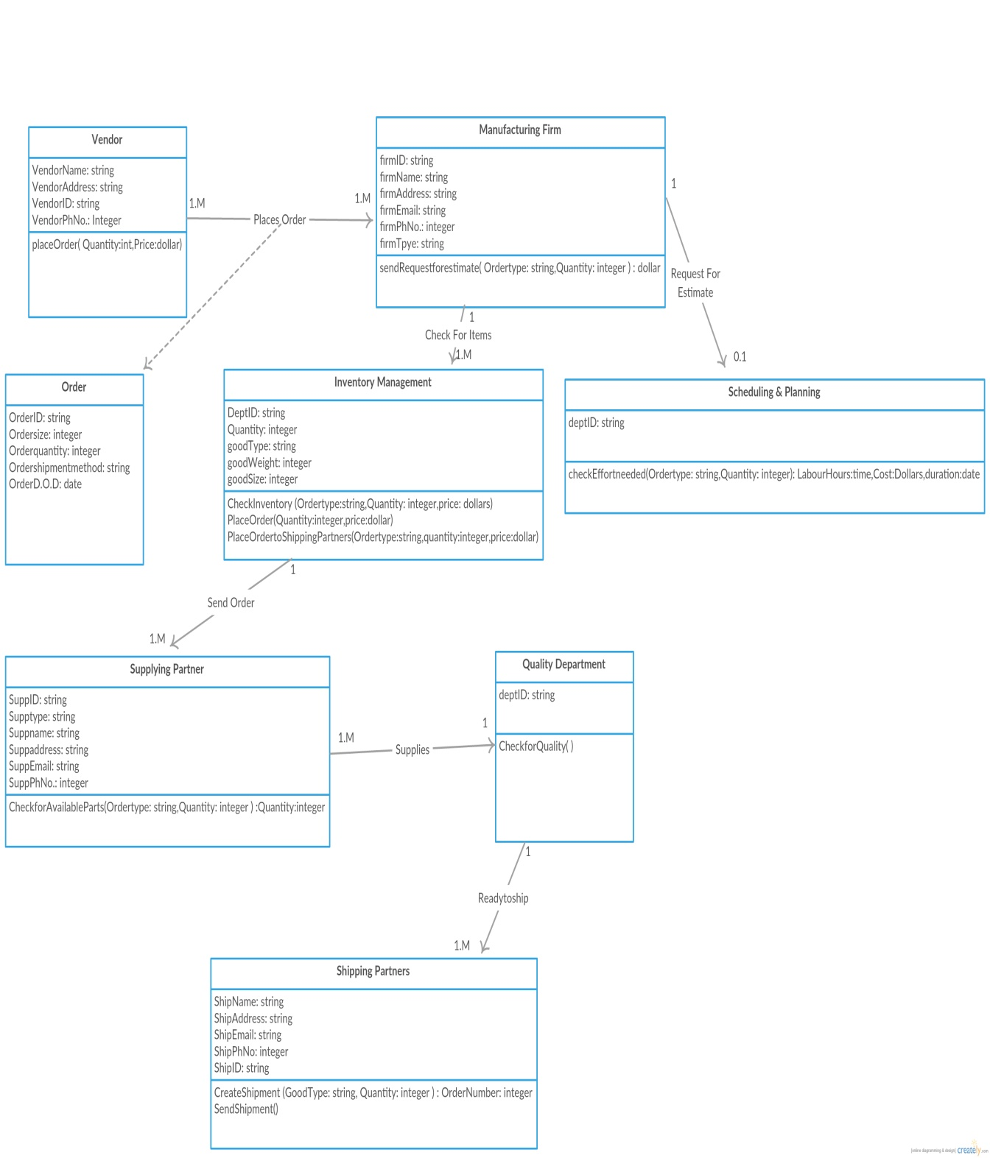

**Prototypes**

**Vendor Login**

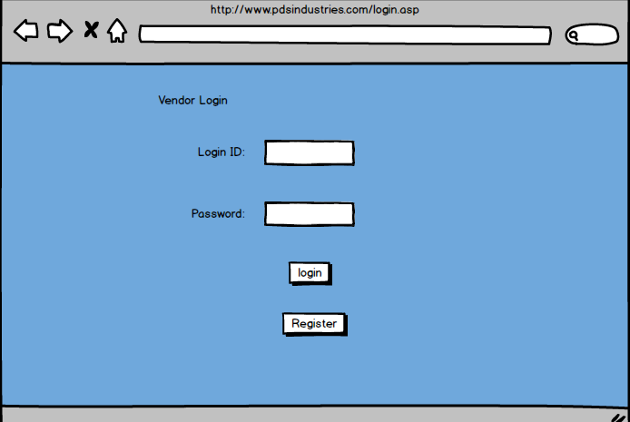

* Every vendor will be given login credentials to place an order with PDS.
* Vendor needs to enter their respective Login ID and password in this module.
* New vendors should first register with the PDS before login.

**Vendor registration**

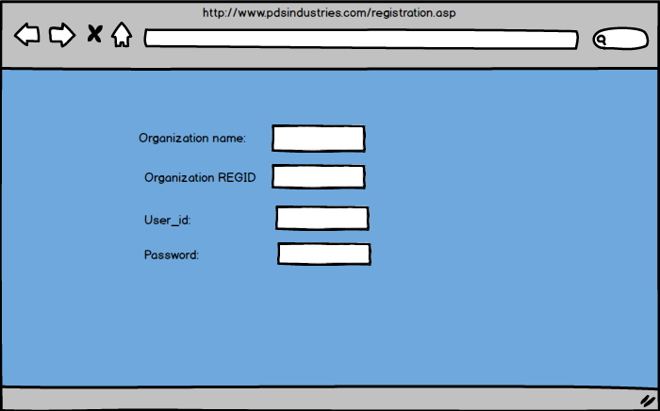

* For a new vendor to contact with PDS, they need to register their organization with PDS.
* The necessary details would be Organization name, a valid registration id of the organization, user_id and password
* PDS would run a back ground check on the organization ID and confirm the login with the organization.

**Home page**

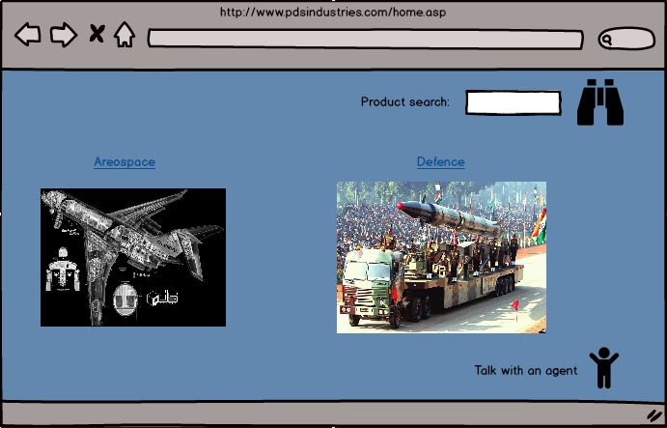

* Home page contains the categories of manufacturing.
* User can choose the required option and go further with the order.

**Aerospace Page**

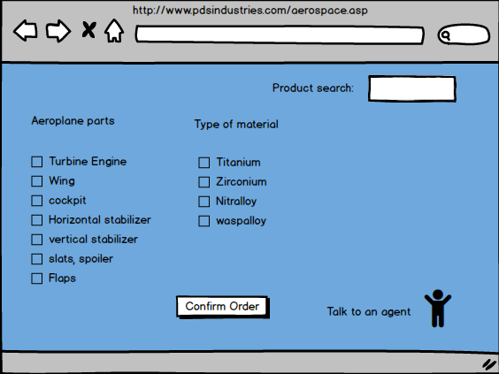

* This shows the catalogue for the order.
* Vendor can choose the required parts for manufacturing and confirm the order.

**Order Status**

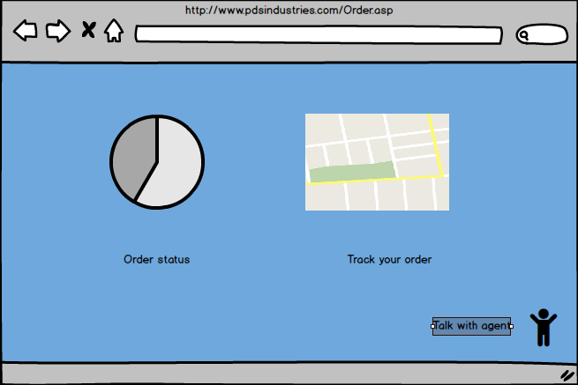

* In this page the vendor can check the status of the order.